  

To Supply Leftover Food to Poor

# Project Overview

The goal of the **To Supply Leftover Food to Poor** project is to effectively handle the logistical coordination issues associated with food collecting, volunteer management, and transportation to several drop-off locations. The solution makes use of the Salesforce platform to facilitate real-time tracking and expedite data management. The long-term objectives of this project are to reduce food waste and assist underprivileged populations while improving operational efficiency, user experience, and data integrity.

# Objectives

## Business Goals:

•Establish a reliable procedure to handle donations of extra food.

•Streamline volunteer, delivery, and collection point coordination to increase the effectiveness of food distribution.

•Make real-time tracking and reporting possible to aid with impact analysis and decision-making.

## Specific Outcomes:

• The creation of unique objects and connections to monitor locations, volunteers, drop-off locations, and job allocations.

• A reporting system that provides up-to-date information on parameters related to food distribution.

• Dashboards that show the distribution of food supplies, volunteer participation, and location-based requirements.

# Salesforce Key Features and Concepts Utilized

This project utilizes several Salesforce features, including:

**•Custom Objects:** For data tracking, we created the Venue, Drop-Off Point, Task, Volunteer, and Execution Details objects.

**•Triggers:** To automatically set distance values, a special Apex trigger called DropOffTrigger was implemented.

**•Lightning App and Custom Tabs:** A FoodConnect Lightning App was created to streamline and organize navigation for all objects.

* + **Sharing Rules**: To make it easier to limit user access based on proximity, sharing rules were configured using distance criteria.

# Detailed Steps to Solution Design

The design and development process included the following steps:

## Data Models: Constructed unique objects with pertinent fields and associations (Lookup and Master-Detail) for the following: Venue, Drop-Off Point, Task, Volunteer, and Execution Details.

## • User Interface Design: Added unique tabs to the FoodConnect Lightning App to facilitate navigation.

## • Logic for Business: DropOffTrigger was created to automatically assign distances to the Distance Calculation field so that rules may be assigned smoothly.

## Screenshots:

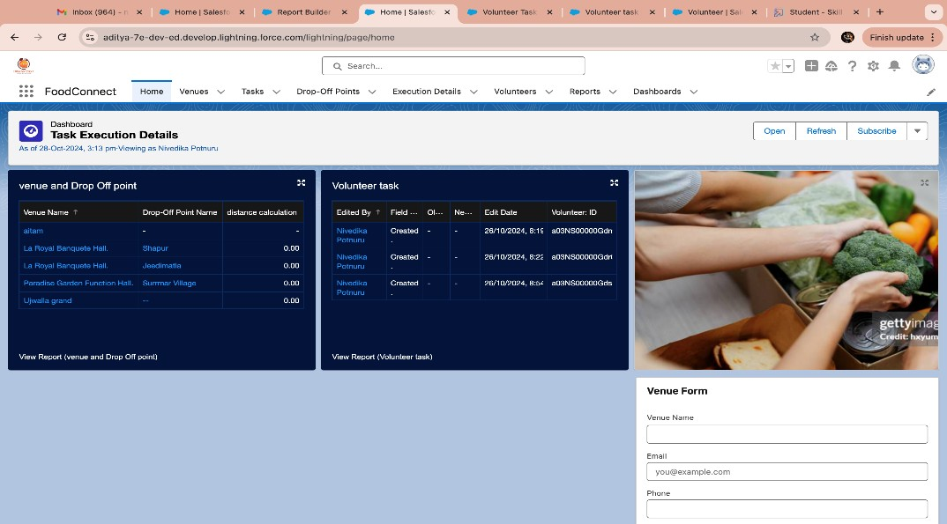**Screenshot of the UI**

## Pujitha Add Screenshot of the Flow.

## 

  

# Testing and Validation

The approach to testing involved:

**• Unit Testing:** Apex Classes and Triggers, particularly DropOffTrigger and custom field updates, were tested.

**• User Interface Testing:** Verified the accuracy of data flow and usability of each UI element across custom tabs and the FoodConnect App.

# Key Scenarios Addressed by Salesforce in the Implementation Project

**• Scenario 1: Food Distribution and Collection Coordination:**

oOverseen by establishing and linking drop-off locations and arranging distances with designated sharing groups.

**• Scenario 2: Volunteer Assignment and Tracking:**

o Ensured effective food collection and delivery assignments by keeping an eye on volunteer duties and availability.

**• Scenario 3: Reporting and comments:**

oMade it possible for volunteers to rate deliveries, track served capacity for upcoming enhancements, and offer comments on delivery.

# Conclusion

**Summary of Achievements:** The project effectively created a streamlined system for handling food donations, organizing volunteers, and delivering them to specified places by utilizing Salesforce. This platform demonstrates a scalable and significant approach to food security by efficiently reducing food waste while advancing the objective of delivering food to underprivileged communities.